Cairo University Faculty of Computers and Information



**CS352 – Software Engineering II**

**Software design specification document**

**2018**

**Project Team**

|  |  |  |  |
| --- | --- | --- | --- |
| **ID** | **Name** | **Email** | **Mobile** |
| 20150274 | Nabawy hussien | snour0138@gmail.com |  |
| 20140006 | Ahmed emam gad | a.emam3920@gmail.com | 01112807193 |
| 20140020 | Ahmed reda zaky | ahmedkhaled19515@gmail.com | 01207082939 |
| 20150260 | Mostafa mohamed |  |  |
|  |  |  |  |
|  |  |  |  |

**[TA/mohamed samir]**

# Class diagram design

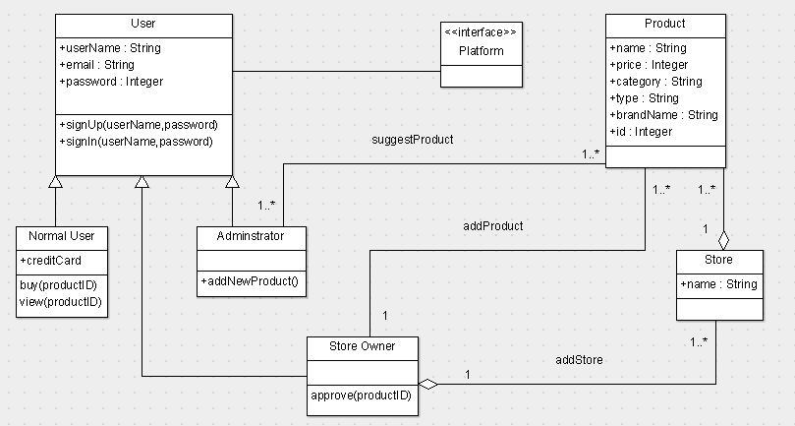

# Sequence diagram design

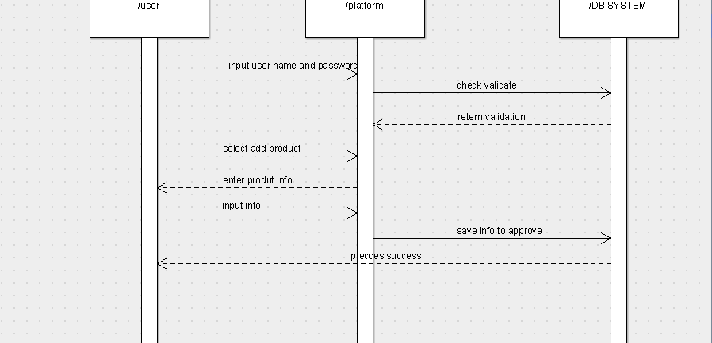

# Github repository link

link of github: https://github.com/ahmedemam22/automatic-robot